**Tableau Dashboard Write Up**

**Background on Data**

The datasets we decided to use used the Prince George’s Health Department and the Maryland Department of Health. From that data, we created our datasets. Our “Data Collection.xlsx” File housed most of our data. This dataset concerned the services provided by the providers, along with the address and contact information. Our “Location.xlsx” dataset contained the geographical knowledge of each provider so that they could be displayed on a map. Our “Provided Services.xlsx” file contains data on the year-to-year numbers of how many providers offer select services in the PG County area.

**Bar Chart of Providers by City**

This bar chart titled "Number of Providers in Each City" displays the number of providers in each city and displays their services offered along with that. The purpose of this visualization is to show people where they can go to receive assistance. This data came from a 2017 behavioral health providers list for Prince George's County.

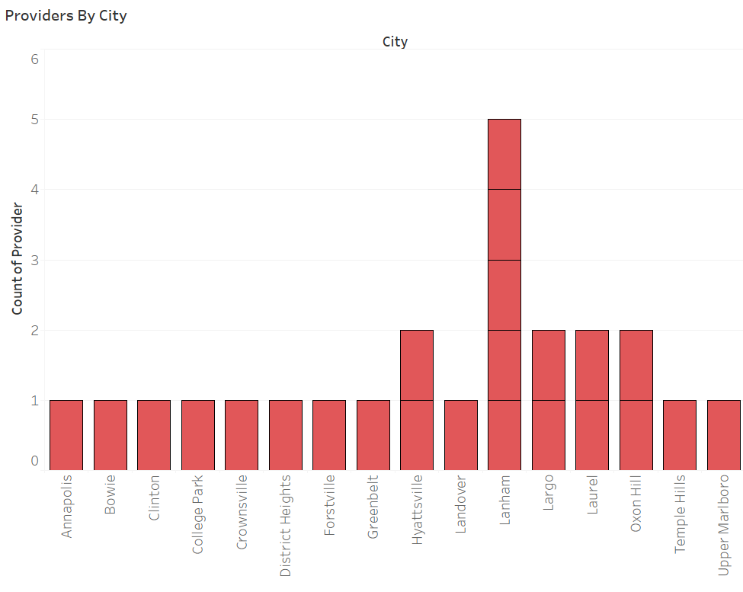

**Map of Providers and Their Services**

This map shows the geographical locations of each provider along with the primary services that they provide, displayed via color-coded dots. The purpose of this visualization is to show where people can go to receive assistance.

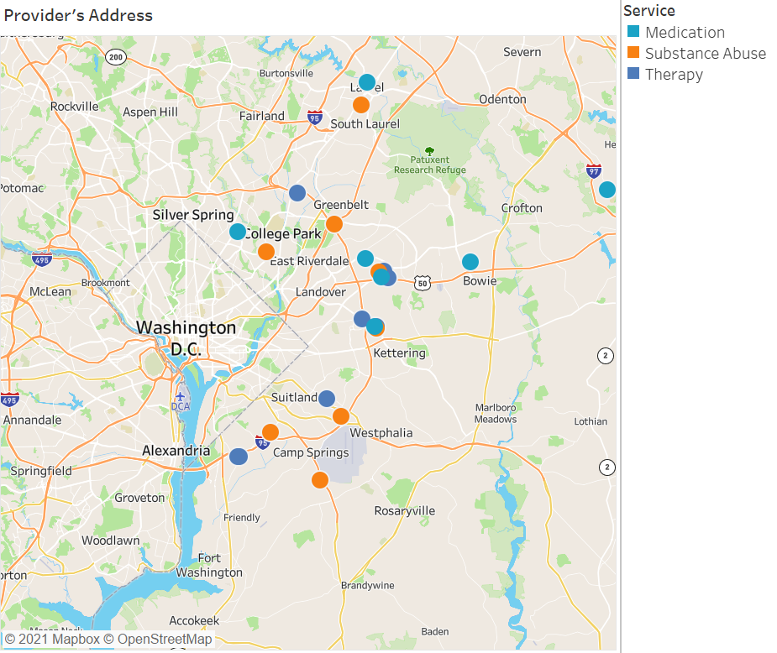

**Pie Charts of Providers by Service(Private Insurance, Medicare/Medicaid, Anger Management)**

These pie charts will display the breakdown of what services these institutions provide their clients. This visualization aims to give people an idea of how common specific treatments are and offer a general idea of where to be treated. Also, to provide them with information on what types of insurances are accepted by what providers.

